HOW TO IMPLEMENT CHATGPT IN DJANGO

MINI PROJECT REPORT

Submitted by

23AK1A33A5 – K. VENKATA TANAY

23AK1A3601 – ANJALI POOJARI

23AK1A3620 – G. HEMASREE

ABSTRACT
How To Implement ChatGPT in Django is a web-based chatbot application developed using the Django framework and Python programming language. The main objective of this project is to demonstrate how a simple chatbot can be implemented using Django by providing an interactive web interface where users can communicate with the chatbot and receive predefined responses.
The system allows users to enter text messages through a chat interface, which are processed by the Django backend. The application analyzes the user's input, compares it with predefined chatbot responses, and returns an appropriate reply instantly. The chatbot also maintains chat history during the session and provides a clear chat option to improve the user experience.
The project is developed using modern web technologies such as Python, Django, HTML, CSS, and JavaScript. Visual Studio Code is used as the development environment, while Django handles URL routing, request processing, template rendering, and application logic. The chatbot interface is designed with a responsive dark theme to provide a clean and user-friendly experience.
This project helps students understand the fundamentals of Django web development, including project structure, URL configuration, views, templates, forms, and frontend-backend communication. It serves as an excellent learning project for beginners who want to build web applications using Python and Django.
Future enhancements include integrating the OpenAI API for AI-powered conversations, storing chat history in a database, implementing user authentication, adding voice input and multilingual support, and deploying the application to a cloud platform for real-world usage.

INTRODUCTION
The rapid growth of Artificial Intelligence (AI) and web technologies has transformed the way users interact with software applications. Chatbots have become an important part of modern applications by providing instant responses, automating communication, and improving user experience. They are widely used in educational platforms, customer support systems, e-commerce websites, healthcare applications, and many other domains.
How To Implement ChatGPT in Django is a web-based chatbot application developed to demonstrate the implementation of a chatbot using the Django framework and Python programming language. The project provides a simple and interactive chat interface where users can enter text messages and receive appropriate predefined responses. The application uses Django's URL routing, views, templates, and request handling mechanisms to process user input and generate responses efficiently.
The chatbot is designed with a clean and responsive user interface using HTML, CSS, and JavaScript, while Django manages the backend logic and communication between the user interface and the application. The system also includes useful features such as chat history and a clear chat option, making the application more interactive and user-friendly.
This project serves as a practical learning model for students who are interested in Python web development and chatbot implementation. It helps in understanding the complete workflow of Django applications, including project creation, application development, template rendering, request-response processing, and frontend-backend integration. The project also provides a strong foundation for future enhancements such as AI-based conversations, database integration, user authentication, multilingual support, and cloud deployment.
Overall, How To Implement ChatGPT in Django demonstrates how a simple chatbot can be successfully developed using Django while providing an easy-to-use and efficient web application for users.

OBJECTIVES

- To develop a web-based chatbot application using the Django framework and Python programming language.
- To provide users with a simple, interactive, and user-friendly chat interface for communicating with the chatbot.
- To process user input efficiently and generate appropriate predefined responses through the Django backend.
- To understand the implementation of Django components such as URL routing, views, templates, and request-response handling.
- To design a responsive and attractive user interface using HTML, CSS, and JavaScript.
- To implement chat history functionality for displaying previous conversations between the user and the chatbot.
- To provide a clear chat feature that allows users to reset the conversation easily.
- To demonstrate the integration of frontend and backend technologies in developing a complete web application.
- To improve knowledge of Python web development and understand the working principles of chatbot applications.
- To provide a strong foundation for future enhancements such as AI integration using the OpenAI API, database storage, user authentication, voice interaction, and cloud deployment.

EXISTING SYSTEM
The existing chatbot systems are mainly available as standalone applications or AI-powered online platforms that require internet connectivity and external APIs to generate responses. Many beginner chatbot implementations are console-based and do not provide an interactive web interface. Such systems often lack features like chat history, user-friendly design, and easy deployment using a web framework.
In many traditional chatbot implementations, users interact with the chatbot through command-line interfaces, making the conversation less engaging and difficult for non-technical users. Some AI chatbot applications also depend on third-party services, which may increase development costs and require API integration and internet access.
Limitations of the Existing System
- Most chatbot applications are console-based and do not provide a web interface.
- Many systems depend on external APIs or internet connectivity.
- Lack of an attractive and user-friendly chat interface.
- No chat history or conversation management in basic implementations.
- Difficult for beginners to understand complete web application development.
- Limited customization and scalability in simple chatbot projects.
- Some chatbot platforms require paid API services for advanced features.
Due to these limitations, there is a need for a simple, web-based chatbot application that demonstrates chatbot implementation using Django while providing an interactive interface, predefined responses, chat history, and easy customization for learning purposes.

PROPOSED SYSTEM
The proposed system, How To Implement ChatGPT in Django, is a web-based chatbot application developed using Python and the Django framework. The application provides a simple and interactive chat interface where users can communicate with the chatbot by entering text messages and receiving predefined responses instantly.
The chatbot processes user requests through the Django backend using URL routing, views, and templates. When a user enters a message, the application analyzes the input, searches for the corresponding predefined response, and displays the appropriate reply in the chat window. The system also maintains chat history during the session and provides a Clear Chat feature to reset the conversation whenever required.
The application is developed using modern web technologies such as Python, Django, HTML, CSS, and JavaScript. The frontend provides a responsive and user-friendly interface, while the Django backend efficiently handles request processing and response generation. This project serves as an educational model for understanding Django web development and chatbot implementation.
Advantages of the Proposed System
- Simple and interactive web-based chatbot interface.
- Fast processing of user requests using the Django framework.
- Responsive and user-friendly chat interface.
- Displays chat history for better conversation tracking.
- Includes a Clear Chat feature for resetting conversations.
- Easy to understand and implement for beginners.
- Demonstrates frontend and backend integration using Django.
- Easily customizable by adding new chatbot responses.
- Provides a strong foundation for AI-based chatbot development.
- Can be extended with OpenAI API, database storage, user authentication, voice interaction, and cloud deployment in future versions.

TECHNOLOGIES USED
- Frontend Technologies
HTML5
- Used to create the structure of the chatbot web pages.
- Provides input fields, buttons, and chat interface elements.
CSS3
- Used to design a responsive and attractive user interface.
- Provides styling for chat bubbles, colors, layouts, and overall appearance.
JavaScript
- Used to improve interactivity and enhance the user experience.
- Handles client-side operations and dynamic behavior when required.

- Backend Technologies
Python
- Used as the core programming language for developing the chatbot logic.
- Processes user requests and generates predefined responses efficiently.
Django
- A high-level Python web framework used to develop the chatbot application.
- Manages URL routing, views, templates, request processing, and response generation.
- Provides a secure, scalable, and maintainable development environment.

- Development Tools
Visual Studio Code
- Used as the primary code editor for writing and managing the project source code.
Git & GitHub
- Used for version control and project management.
- Helps in maintaining project versions and sharing the source code.

- Web Technologies
HTML
- Creates the basic structure of the chatbot interface.
CSS
- Improves the appearance and responsiveness of the web pages.
JavaScript
- Adds dynamic functionality and improves user interaction.

- Operating System
Windows
- Used as the development platform for implementing and testing the chatbot application.

These technologies work together to create a simple, responsive, secure, and user-friendly chatbot application using the Django framework.

SYSTEM ARCHITECTURE
The How To Implement ChatGPT in Django project follows a three-tier architecture consisting of the Presentation Layer, Application Layer, and Processing Layer. This architecture ensures proper communication between the user interface and the chatbot logic while making the application simple, scalable, and easy to maintain.
- Components Description
1. Presentation Layer (Frontend)
- Developed using HTML, CSS, and JavaScript.
- Provides an interactive chat interface for users.
- Accepts user messages and displays chatbot responses.
- Maintains chat history and supports the Clear Chat feature.
2. Application Layer (Backend)
- Developed using Python and the Django Framework.
- Processes user requests received from the frontend.
- Handles URL routing, views, templates, and chatbot logic.
- Matches user input with predefined responses and generates appropriate replies.
3. Processing Layer
- Contains the chatbot response logic.
- Analyzes the user's message.
- Searches predefined responses.
- Returns the appropriate response to the user interface.
- Workflow
- The user opens the chatbot web application.
- The user enters a message in the chat box.
- The request is sent to the Django backend.
- Django processes the request through the Views module.
- The chatbot compares the user's message with predefined responses.
- The appropriate response is generated.
- The response is displayed in the chat interface.
- The conversation is stored in the current session until the user clears the chat.
Architecture Flow
User
│
▼
Chat Interface
(HTML, CSS, JavaScript)
│
▼
Django Framework
(URL Routing)
│
▼
Views.py
│
▼
Chatbot Logic
(Predefined Responses)
│
▼
Response Generated
│
▼
Chat Interface
The above architecture provides a simple and efficient flow of communication between the user and the chatbot. It demonstrates how Django integrates frontend and backend components to build an interactive web-based chatbot application.

MODULES DESCRIPTION
The How To Implement ChatGPT in Django application is divided into the following modules:

13.1 User Interface Module
This module provides an interactive chat interface where users can enter messages and receive responses from the chatbot. It is developed using HTML, CSS, and JavaScript to provide a responsive and user-friendly experience.

13.2 Request Processing Module
This module receives user input from the chat interface and sends it to the Django backend. It handles HTTP requests and forwards the message for processing.

13.3 Chatbot Logic Module
This is the core module of the application. It processes the user's message, compares it with predefined chatbot responses, and generates an appropriate reply.

13.4 Response Management Module
This module displays chatbot responses in the chat window. It ensures that responses are shown in a proper conversational format and updates the chat interface dynamically.

13.5 Chat History Module
This module stores the current conversation during the user's session. It displays previous messages and supports the Clear Chat feature to reset the conversation whenever required.

DATABASE DESIGN

The How To Implement ChatGPT in Django project uses SQLite as the default database provided by the Django framework. SQLite is a lightweight, file-based relational database that stores application data in a single database file. It is easy to configure, requires no separate database server, and is well suited for small and educational projects.

In this project, SQLite is mainly used to manage the application's data and configuration. Since the chatbot currently generates predefined responses and maintains chat history during the user session, no complex database tables are required. However, SQLite provides the flexibility to store user information, chatbot conversations, and application data in future versions.

Features of SQLite

Lightweight and serverless database.

Easy to configure with Django.

Stores data in a single database file (db.sqlite3).

Suitable for small and medium-sized applications.

Supports SQL queries for efficient data management.

Reliable, secure, and easy to maintain.

Future Database Enhancements

The database can be extended to store:

User account information.

Chat history and conversation logs.

Frequently asked questions (FAQs).

User feedback and ratings.

AI-generated responses.

Application settings and configuration.

SQLite provides a strong foundation for this project and can be upgraded to databases such as MySQL or PostgreSQL when the application is deployed for large-scale usage.

IMPLEMENTATION SCREENSHOTS
The following screenshots demonstrate the successful implementation of the How To Implement ChatGPT in Django application.
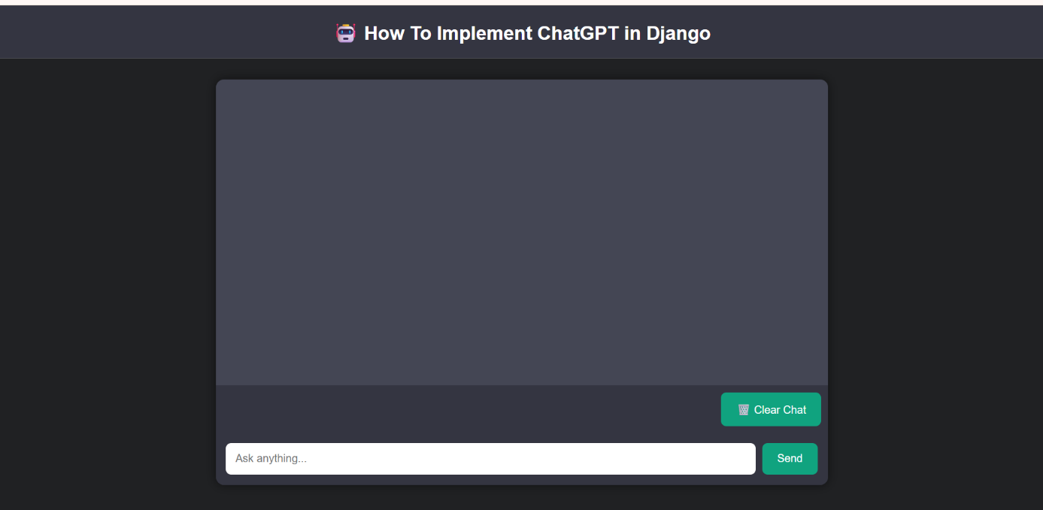
Description:
This screenshot shows the home page of the chatbot application. The interface includes the project title, chat window, input text box, Send button, and Clear Chat button. The user can enter messages and interact with the chatbot through this interface.
Screenshot 2: Chatbot Response
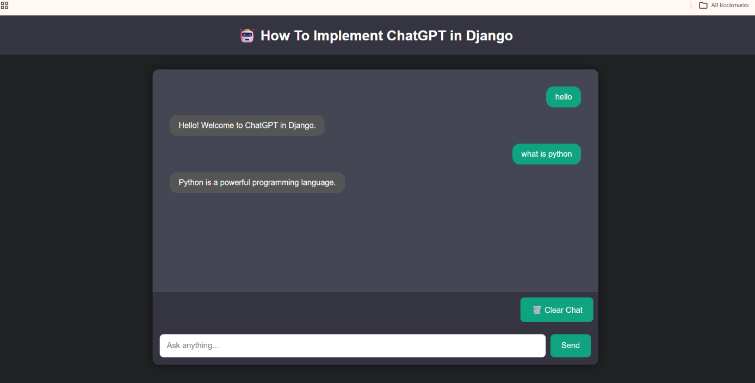
Description:
This screenshot demonstrates the chatbot responding to user queries. When the user enters messages such as "Hello" and "What is Python?", the Django backend processes the request and displays the appropriate predefined responses in the chat window.
Screenshot 3: Clear Chat Functionality
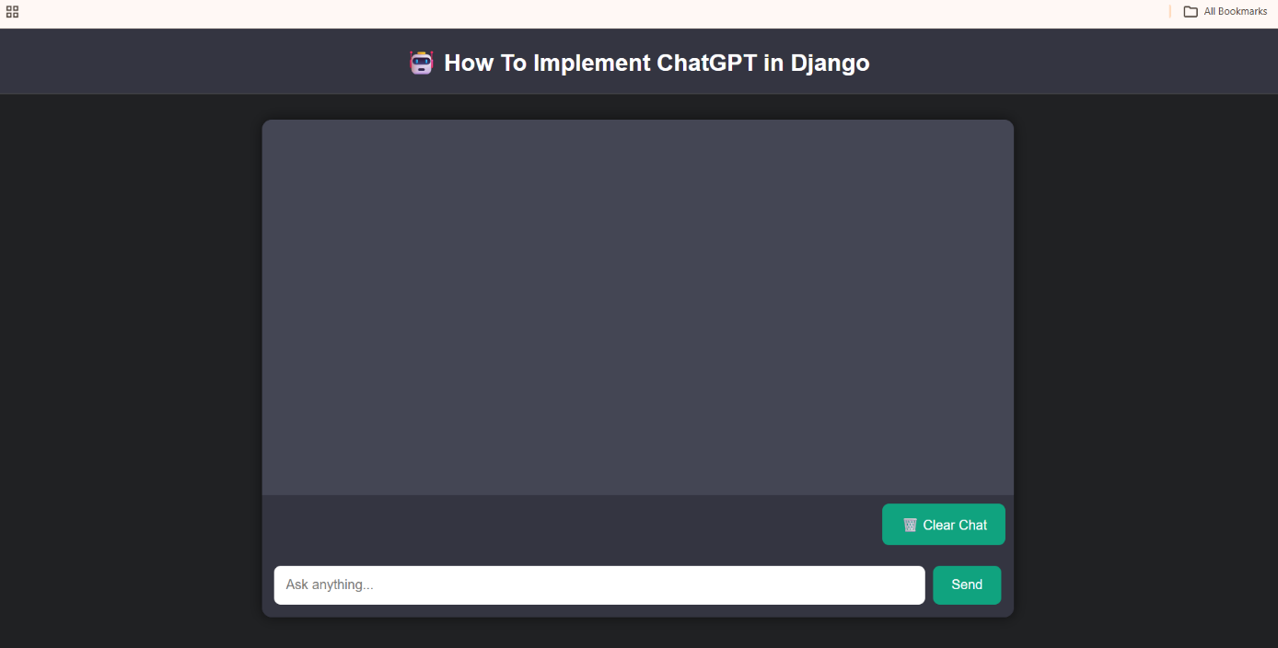
Description:
This screenshot shows the Clear Chat functionality. When the user clicks the Clear Chat button, the conversation is removed from the chat window, allowing the user to start a new conversation.

ADVANTAGES
The How To Implement ChatGPT in Django project offers several advantages for both users and developers. The major advantages are listed below:
- Provides a simple and user-friendly chatbot interface.
- Developed using the Django framework, which is secure and reliable.
- Generates quick responses to user queries.
- Easy to understand and implement for beginners.
- Maintains chat history during the user session.
- Includes a Clear Chat feature to reset conversations.
- Uses Python, making the application easy to maintain and extend.
- Responsive interface that works on different screen sizes.
- Demonstrates frontend and backend integration effectively.
- Can be easily enhanced by integrating AI APIs, databases, user authentication, and cloud deployment in future versions.
Overall, the project provides a practical understanding of Django web development and chatbot implementation while offering a clean, interactive, and efficient user experience.

FUTURE ENHANCEMENTS
The current version of How To Implement ChatGPT in Django is a simple chatbot application developed for learning and demonstration purposes. In the future, the project can be enhanced by adding advanced features to improve its functionality and user experience.
Future Enhancements
- Integrate the OpenAI API to provide intelligent and AI-powered conversations.
- Store chat history permanently using databases such as MySQL or PostgreSQL.
- Implement User Registration and Login for personalized chatbot interactions.
- Add Voice Input and Voice Response functionality.
- Support multiple languages to communicate with users from different regions.
- Enable file and image upload for more interactive conversations.
- Integrate Natural Language Processing (NLP) to understand complex user queries more accurately.
- Deploy the application on cloud platforms such as AWS, Render, or PythonAnywhere for public access.
- Develop a mobile-friendly version for smartphones and tablets.
- Improve the chatbot by adding more predefined responses and support for frequently asked questions (FAQs).
These enhancements will make the chatbot more intelligent, scalable, and suitable for real-world applications in education, customer support, healthcare, and business sectors.

CONCLUSION
The How To Implement ChatGPT in Django project successfully demonstrates the development of a simple and interactive web-based chatbot using the Django framework and Python programming language. The application provides a user-friendly interface where users can communicate with the chatbot and receive predefined responses efficiently.
Throughout the project, important concepts such as Django project structure, URL routing, views, templates, frontend-backend integration, and request-response processing were successfully implemented. The chatbot also includes useful features such as chat history and a Clear Chat option, making the application more interactive and easy to use.
This project serves as an excellent learning platform for beginners who want to understand Django web development and chatbot implementation. It also provides a strong foundation for future improvements, including AI-powered conversations, database integration, user authentication, voice interaction, multilingual support, and cloud deployment.
Overall, the project achiev ed all its objectives and demonstrates how Django can be effectively used to build simple, responsive, and scalable chatbot applications. It enhances practical knowledge of Python web development while preparing students for developing more advanced AI-based web applications in the future

REFERENCES
• Django Software Foundation. Django Documentation. Available at: https://docs.djangoproject.com/
• Python Software Foundation. Python Documentation. Available at: https://docs.python.org/3/
• OpenAI. OpenAI API Documentation. Available at: https://platform.openai.com/docs
• Mozilla Developer Network (MDN). HTML, CSS and JavaScript Documentation. Available at: https://developer.mozilla.org/
• W3Schools. HTML, CSS, JavaScript and Django Tutorials. Available at: https://www.w3schools.com/
• Visual Studio Code. Official Documentation. Available at: https://code.visualstudio.com/docs
• GitHub. GitHub Documentation. Available at: https://docs.github.com/

